«Title» «FirstName» «LastName»
«Address»
«PostCode»

Dear «FirstName»

Your 1 month free Bicycle Insurance from Electric Rider is due to expire on «CoverStartDate». If you would like to continue cover for your bike, you will need to renew.

We’ve prepared a renewal quote based on your current policy which will cost £«DiscountedPremiumIncludingIPT» for the year, including our 25% renewal discount*.

This quote includes a 25%* loyalty discount on your quote. If you were new to us today, it would cost you «PremiumIncludingIPT» . Please note that this discount will also expire on «CoverStartDate».

This quote is for our Essentials level of cover, but you will have the option to switch over to our Performance or Ultimate cover if they suit your needs better.

If you have more than one bike in your household, you can add this to your policy at renewal and get 60% off that too. Remember that you are able to log in and adjust your policy all year round too.

we don’t auto renew, so you need to act

Renewing your cover is easy.
- Simply use this link to log into your account
- Once logged in select “renew policy” to review and amend your cover if necessary
(If you need to add another bike, we offer a 60% multi-bike discount and family cover as standard)
- Select which payment option suits you best, and you’re done

AN AWARD WINNING 5 STAR SERVICE


We took all of our claims in house in 2019, and feedback from customers who have had to claim through us has been exceptional. This is a testament to our dedicated claims team who have been working tirelessly over the past 2 years to bring you the very best claims experience.

If you need to claim on your policy, you will be able to speak to a knowledgeable cyclist who will look to repair or replace your bike as quick as humanly possible through our extensive trade network. We were delighted to have been awarded “Claims Team of the Year” at the 2021 Insurance Times Claims Excellence Awards. Should you need to claim, you will be dealing with very best.

Read what Andrea and Paolo has to say about a recent claim with our team:

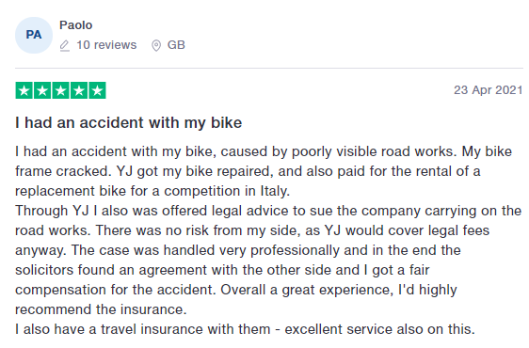
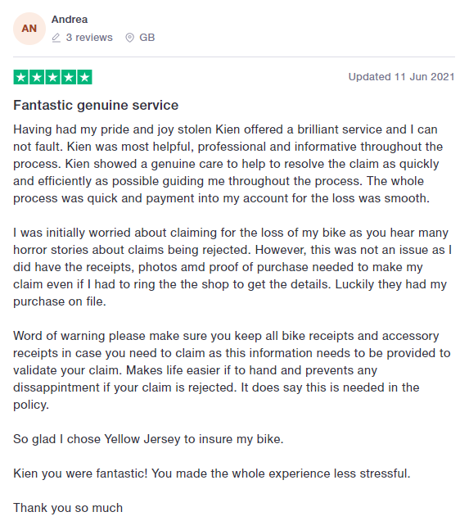

And remember, that claiming on your policy will not affect your renewal price the following year.

PLEASE DON’T FORGET TO READ ALL INFORMATION AND CHECK IT’S CORRECT

Enclosed in this document is a Statement of Facts and our Terms of Business. If you would like printed versions of your documents, they are available on request free of charge. Our Terms of Business detail our services as an insurance broker separate to those of the insurer. Please make sure you take extra care when looking at the sections; our service, our product range, the range of insurers used and your responsibilities.

For future reference, all information is available within the customer area of our website, where you can make changes to your policy and personal information. You can log in to your account here.

THE LEGAL BIT
At Yellow Jersey, we source and arrange products but do not offer advice or make recommendations when arranging your insurance. This policy is suitable for any eligible cyclist wishing to insure their bicycle(s), accessories, additional wheelsets, helmet and clothing against theft and accidental damage, in addition to legal liabilities which may arise out of the use of a bike for periods of up to one year, with the option to renew at the end of the insurance period.

The Essentials level of cover is suitable for cyclists who want cover for their bikes while cycling in the UK. You must make your own decision as to whether this policy is suitable for your specific needs. It is always a good idea to shop around, but be careful to compare like for like cover.

QUESTIONS
If you have any questions please send an email to support@yellowjersey.co.uk or call 0333 003 0046, Mon to Fri 9am to 5pm.

Thank you again for choosing Yellow Jersey,

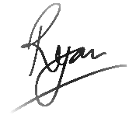
Ryan Georgiades
Managing Director

*The renewal discount cannot be used in conjunction with any other discount.

STATEMENT OF FACT

The information shown in this document is a record of the information you have provided to us and is the basis of your insurance contract. The information has been used when calculating the price paid and terms applied. Please advise us immediately if any of the information is incorrect.

Period of Insurance | «CoverStartDate» to «RenewalDate»
Reason for Issue | Renewal Invite
Policy Level | «PolicyLevel»
Name | «Title» «FirstName» «LastName»
Address | «Address»  «PostCode»
Contact Info | Email: «Email»  Mobile: «Mobile»
Your Date of Birth | «DateOfBirth»
Are you a resident in the UK? Yes
Have you ever been convicted of a criminal offence which you are required to disclose under the Rehabilitation of Offenders Act at the date of this insurance application? No
Please state the number of claims you have made in the last 3 years in relation to any cover you are now requesting: «NumberOfClaimsInLastThreeYears»
Have you ever had a policy cancelled, voided or renewal refused? No

Bicycle(s) on Cover
«TableStart:tblCycles»No. «CycleNumber» | Make: «Make» | Model: «Model» | Value: £«Value» | Type: «Type»
«TableEnd:tblCycles»

ADDITONAL COVER REQUESTED
Value of All Fixed Accessories | £«AccessoriesValue»
Value of Additional Wheelsets | £«WheelsetsValue»
Value of Helmet & Clothing | £«HelmetAndClothingValue»

A current schedule of insurance can be found by logging in into the customer area at yellowjersey.co.uk, login here.

