«Title» «FirstName» «LastName»
«Address»
«PostCode»

Dear «FirstName»

Your annual bicycle and annual travel insurance are both due for renewal on «CoverStartDate».

We’ve prepared a bicycle renewal quote based on your current policy which will cost £«BicycleTotalPayable» for the year.

This quote includes a 25%* loyalty discount on your quote, if you were new to us today, it would cost you «BicyclePremiumIncludingIPT». Please note that this discount will also expire on «CoverStartDate».

If you’ve been lucky enough to add to your fleet this year, you can add this to your policy at renewal and get 60% off that too. Remember that you are able to log in and adjust your policy all year round too.

Your annual travel insurance is due for renewal on «TravelCoverStartDate» and again we’ve prepared a renewal quote based on your current policy which will cost £«TravelTotalPayable» for the year.

we don’t auto renew, so you need to act

Renewing your cover is easy.
- Simply use this link to log into your account
- Once logged in select “renew policy” to review and amend your cover if necessary
(If you need to add another bike, we offer a 60% multi-bike discount and family cover as standard)
- Select which payment option suits you best, and you’re done

AN AWARD WINNING 5 STAR SERVICE


We took all of our claims in house in 2019, and feedback from customers who have had to claim through us has been exceptional. This is a testament to our dedicated claims team who have been working tirelessly over the past 2 years to bring you the very best claims experience.

If you need to claim on your policy, you will be able to speak to a knowledgeable cyclist who will look to repair or replace your bike as quick as humanly possible through our extensive trade network. We were delighted to have been awarded “Claims Team of the Year” at the 2021 Insurance Times Claims Excellence Awards. Should you need to claim, you will be dealing with very best.

Read what Andrea and Paolo has to say about a recent claim with our team:

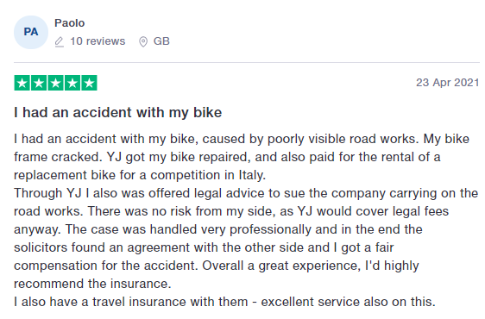
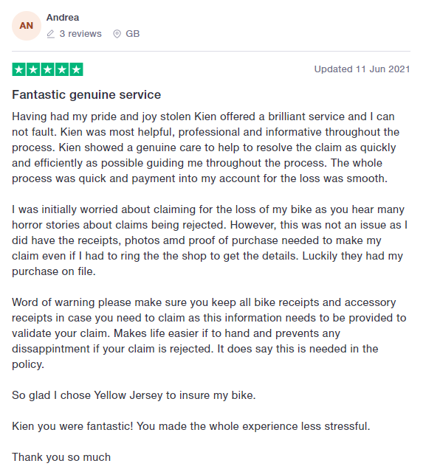

And remember, that claiming on your policy will not affect your renewal price the following year.

PLEASE DON’T FORGET TO READ ALL INFORMATION AND CHECK IT’S CORRECT

Enclosed in this document is a statement of facts and our terms of business. If you would like printed versions of your documents, they are available on request free of charge. Our Terms of Business detail our services as an insurance broker separate to those of the insurer. Please make sure you take extra care when looking at the sections; our service, our product range, the range of insurers used and your responsibilities.

For future reference, all information is available within the customer area of our website, where you can make changes to your policy and personal information. You can log in to your account here.

THE LEGAL BIT
«LegalTierText»

This Travel Insurance policy is suitable for any eligible person wishing to purchase travel insurance to cover emergency medical care and repatriation should they injure themselves while cycling, including while cycle racing, outside of the UK.

In addition, this policy is suitable for any eligible person wishing to purchase travel insurance to cover the following whilst on their trip; cancellation and curtailment, emergency medical treatment, personal effects, valuable and delayed baggage, travel delay and holiday abandonment, missed departure, personal accident, personal liability, cycle hire, cycle breakdown, cycle race/event fee cancellation, gadgets and personal money. This policy provides no cover for any claim occurring directly or indirectly as a result of a pre-existing medical condition. You must make your own decision as to whether this policy is suitable for your specific needs.

It is always a good idea to shop around, but be careful to compare like for like cover.

Last year your total annual or annualised bicycle premium** was £ MERGEFIELD BicycleAnnualisedPremium \* MERGEFORMAT «BicycleAnnualisedPremium».
Last year your total annual or annualised travel premium** was £«TravelAnnualisedPremium».

Questions
If you have any questions please send an email to support@yellowjersey.co.uk or call 0333 003 0046, Mon to Fri 9am to 5pm.

Thank you again for choosing Yellow Jersey.


Ryan Georgiades
Managing Director

*The renewal discount cannot be used in conjunction with any other discount. We are unable to offer a 25% discount on travel renewals
**An annualised premium includes any adjustments you may have made during the year, for example;
- The example annual premium at the start of a policy was: £300
- Six months in, a bike is added at an additional premium of: £50 – (this represents an annual equivalent cost of £100)
- Total amount paid for last year’s Insurance: £350
- Total annualised premium for the example is: £400

BICYCLE INSURANCE STATEMENT OF FACT

The information shown in this document is a record of the information you have provided to us and is the basis of your insurance contract. The information has been used when calculating the price paid and terms applied. Please advise us immediately if any of the information is incorrect.

Period of Insurance | «BicycleCoverStartDate» to «BicycleRenewalDate»
Reason for Issue | Renewal Invite
Policy Level | «PolicyLevel»
Name | «Title» «FirstName» «LastName»
Address | «Address»  «PostCode»
Contact Info | Email: «Email»  Mobile: «Mobile»
Your Date of Birth | «BicycleDateOfBirth»
Are you a resident in the UK? Yes
Have you ever been convicted of a criminal offence which you are required to disclose under the Rehabilitation of Offenders Act at the date of this insurance application? No
Please state the number of claims you have made in the last 3 years in relation to any cover you are now requesting: «NumberOfClaimsInLastThreeYears»
Have you ever had a policy cancelled, voided or renewal refused? No

Bicycle(s) on Cover
«TableStart:tblCycles»No. «CycleNumber» | Make: «Make» | Model: «Model» | Value: £«Value» | Type: «Type»
«TableEnd:tblCycles»

ADDITONAL COVER REQUESTED
Additional DNA+ Kits | «NumberOfAdditionalDNAKits»
Value of All Fixed Accessories | £«AccessoriesValue»
Value of Additional Wheelsets | £«WheelsetsValue»
Value of Helmet & Clothing | £«HelmetAndClothingValue»

A current schedule of insurance can be found by logging in into the customer area at yellowjersey.co.uk, login here.

TRAVEL INSURANCE STATEMENT OF FACT

The information shown in this document is a record of the information you have provided to us and is the basis of your insurance contract. The information has been used when calculating the price paid and terms applied. Please advise us immediately if any of the information is incorrect.

Period of Insurance | «TravelCoverStartDate» to «TravelRenewalDate»
Reason for Issue | Renewal Invite
Name | «Title» «FirstName» «LastName»
Address | «Address»  «PostCode»
Contact Info | Email: «Email»  Mobile: «Mobile»
Who requires cover? | «GroupType»
Where are you travelling? | «GeographicalArea»
Person(s) on Cover | PLEASE REFER TO THE SCHEDULE OF PERSONS ON COVER
What is the maximum trip duration?  (annual policies only) | «TripDuration»
Have you or any of your travelling companions ever suffered from, been investigated for, treated for or diagnosed with;
- Any cancer or malignant condition?
- Any lung, heart-related or circulatory condition (including angina or hypertension)?

Answer: «IsDiagnosed»
Do you or your travelling companions have any condition that has required referral to or consultation with a specialist or hospital for treatment, investigation or check-up within the past 12 months?

Answer: «ReferralRequired»

IMPORTANT
You have agreed to the following:
- No cover is available under this policy for any claim which is directly or indirectly linked to the medical condition(s) which caused you to answer 'Yes' to either of the questions above.
- I have never been convicted of a criminal offence which is required to be disclosed under the rehabilitation of offenders’ act at the date of this insurance application.
- I have never had a policy cancelled, voided or renewal refused.
- My trip has not yet started.
- My trip will start and end in my country of residence.
- Where single trip is selected the dates selected above cover the full duration of my trip.

A current schedule of insurance can be found by logging in into the customer area at yellowjersey.co.uk, login here.

Schedule of Person(s) on Cover

«TableStart:tblTravellers»No. «TravellerNumber» | Name: «FirstName» «Surname» | DOB: «DateOfBirth»
«TableEnd:tblTravellers»

